ASSIGNMENT 1

Git repositories : <https://github.com/avibansal/Ubuntu-assignment>

Name: Avi bansal

Roll NO:243505

1.

1 sudo touch songs{1..6}.mp3

2 sudo touch snap{1..6}.jpg

3 sudo touch film{1..6}.avi

4 ls -l

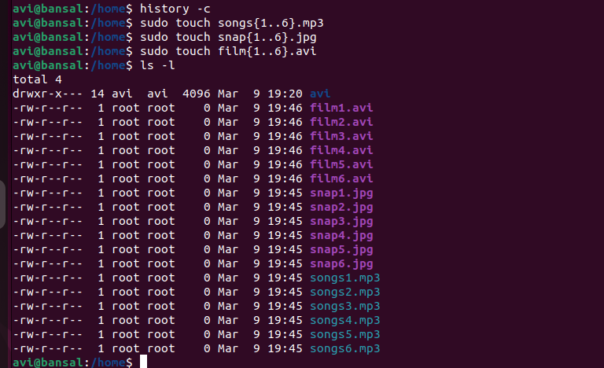

2.

1 sudo mv songs{1..6}.mp3 ~/Music/

2 sudo mv snap{1..6}.jpg ~/Pictures/

3 sudo mv film{1..6}.avi ~/Videos/

4 ls ~/Music/ ~/Pictures/ ~/Videos/

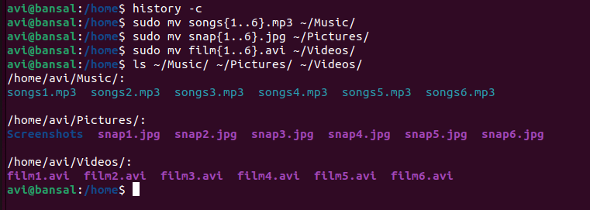

3-4.

1 sudo mkdir friends family work

2 sudo cp ~/Music/\*{1..2}.\* friends/

3 sudo cp ~/Pictures/\*{1..2}.\* friends/

4 sudo cp ~/Videos/\*{1..2}.\* friends/

5 sudo cp ~/Music/\*{3..4}.\* family/

6 sudo cp ~/Pictures/\*{3..4}.\* family/

7 sudo cp ~/Videos/\*{3..4}.\* family/

8 sudo cp ~/Music/\*{5..6}.\* work/

9 sudo cp ~/Videos/\*{5..6}.\* work/

10 sudo cp ~/Pictures/\*{5..6}.\* work/

11 ls

12 ls family friends work

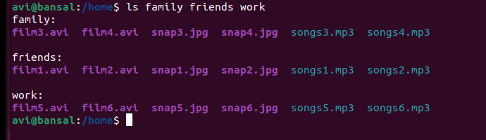

6-7

1 sudo rm -r family

2 ls

3 sudo rm -r friends

4 ls

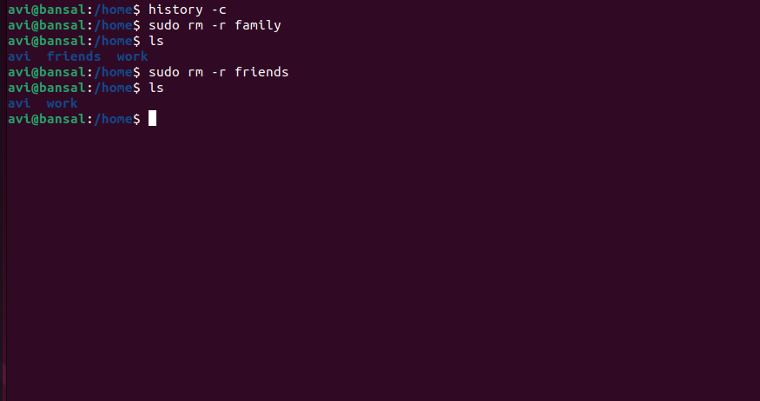

8-10.

1 sudo adduser tom

2 sudo adduser bob

3 sudo adduser sam

4 sudo adduser prince

5 sudo addgroup dac

6 sudo addgroup dbda

7 sudo addgroup ditiss

8 sudo adduser tom --gid 1005

9 sudo adduser tom dac

10 sudo adduser bob dbda

11 sudo adduser sam ditiss

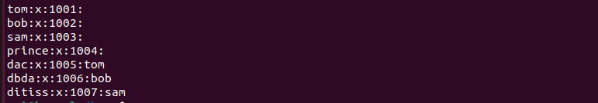

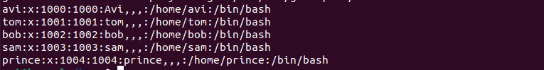

11.

1 ls

2 whereis /tmp

3 ls -l

4 cd ..

5 ls -l

6 sudo mkdir tmp/iacsd

7 cd tmp

8 ls

9 mkdir iacsd

10 touch iacsd/project-{1..4}

11 ls iacsd

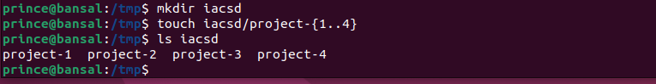

12.

18 su prince

19 sudo chown tom /tmp/iacsd/project-1

20 sudo chgrp dac /tmp/iacsd/project-2

21 ls -l /tmp/iacsd/

22 sudo chown tom /tmp/iacsd/project-3

23 chmod 600 /tmp/iacsd/project-3

24 sudo chmod 600 /tmp/iacsd/project-3

25 sudo chgrp dbda /tmp/iacsd/project-4

26 chmod 070 /tmp/iacsd/project-4

27 ls -l /tmp/iacsd/

28 sudo chmod 070 /tmp/iacsd/project-4

29 ls -l /tmp/iacsd/

